**INTRODUCTION**

**Project Title:**  CookBook - Your Virtual Kitchen Assistant

|  |  |  |
| --- | --- | --- |
| Team Leader | Kanmani G | kanmanikanu09@gmail.com |
| Team Members | Nandhini K | Nandhinik2405@gmail.com |
| Team Members | Monica M | monicamadheswaran20@gmail.com |
| Team Members | Jothi G | jothimaayu65@gmail.com |

**PROJECT OVERVIEW:**  
CookBook is an innovative web application designed for users to explore, organize, and create recipes effortlessly. It caters to both beginner and professional chefs, providing an intuitive user experience and a vast collection of diverse recipes.

**PURPOSE:**

CookBook aims to revolutionize the way users interact with recipes by offering a seamless platform for discovering, saving, and sharing culinary inspirations. The main goals are:

* **User-Friendly Experience** – Easy navigation for discovering and managing recipes.
* **Comprehensive Recipe Management** – Advanced search and categorization for efficient organization.
* **Modern Tech Stack** – Utilizing React.js and Rapid API for enhanced functionality.

**FEATURES:**

* **Recipe API Integration** – Fetches meals from the MealsDB API.
* **Visual Recipe Browsing** – Image-based navigation of categories.
* **Search Functionality** – Easily find recipes using keywords.
* **Interactive UI** – Built using modern design principles for a smooth experience.

**ARCHITECTURE**

**Component Structure**

The application is divided into three main sections:

* **Pages** – Full-page components (Home, Category, Recipe Details).
* **Components** – Reusable UI elements (Navbar, Search Bar, Recipe Cards).
* **Styles** – CSS and styling files.

**State Management**

* **Global State:** Managed using React Context API.
* **Local State:** Controlled via React's useState for component-level updates.

**Routing**

Implemented using React Router to enable seamless navigation between pages.

**SETUP INSTRUCTIONS**

**Prerequisites**

* **Node.js & npm** – Install from [Node.js website](https://nodejs.org/).
* **React.js** – Set up a new project using:

npx create-react-app my-react-app

cd my-react-app

npm start

**Installation Steps**

1. **Clone the repository**

git clone [repository URL]

1. **Navigate into the project directory**

cd recipe-app-react

1. **Install dependencies**

npm install

1. **Set up environment variables** (if required) by creating a .env file and adding necessary API keys.
2. **Start the development server**

npm start

1. **Access the application**  
   Open http://localhost:3000 in your web browser.

**FOLDER STRUCTURE**

The project is structured into different directories for better organization and maintainability. Below is an overview of the folder structure.

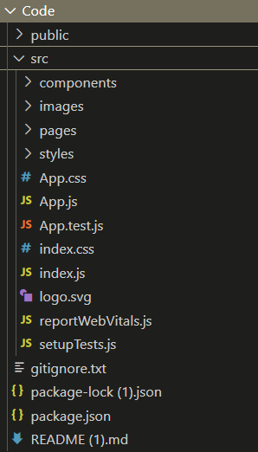

**Client**

The **client** folder (inside src/) contains the core files of the frontend application. It consists of:

* **Components:** Houses all reusable UI components such as buttons, cards, and the navigation bar.
* **Pages:** Contains full-page components, including the homepage, recipe details page, and category listings.
* **Styles:** Includes all CSS or SCSS files to style the application.
* **Assets:** Stores images, icons, and other static files used throughout the app.

Example structure inside src/:

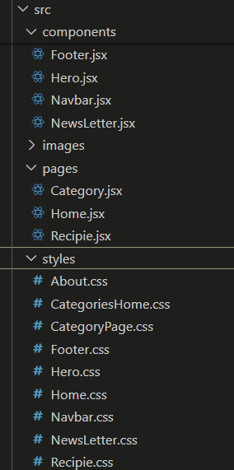

**RUNNING THE APPLICATION**

To start the frontend server, run:

npm start

Then, open http://localhost:3000 in your browser.

**COMPONENT DOCUMENTATION**

**KEY COMPONENTS**

Below are the major components of the **CookBook** application, along with their purpose and props:

**1. Navbar Component (Navbar.js)**

**Purpose:**

* Provides site-wide navigation.
* Contains links to **Home**, **Categories**, and **Search**.

**Props:**

* logo (string): Path to the logo image.
* menuItems (array): List of menu items for navigation.

**2. Hero Component (Hero.js)**

**Purpose:**

* Displays an introduction to the application.
* Contains a call-to-action button to explore recipes.

**Props:**

* title (string): Main heading text.
* subtitle (string): Supporting description text.
* buttonText (string): Label for the action button.

**3. Recipe Card Component (RecipeCard.js)**

**Purpose:**

* Displays a brief summary of a recipe, including an image, title, and category.
* Redirects users to the detailed recipe page when clicked.

**Props:**

* recipe (object): Contains id, title, image, and category.

**4. Category Component (Category.js)**

**Purpose:**

* Displays different categories of meals.
* Allows users to filter recipes by category.

**Props:**

* categoryName (string): Name of the category.
* image (string): Category thumbnail.

**5. Recipe Details Component (RecipeDetails.js)**

**Purpose:**

* Displays a full recipe, including ingredients, instructions, and a demo video.

**Props:**

* recipeId (string): Unique ID to fetch the recipe details.

**REUSABLE COMPONENTS**

**1. Search Bar Component (SearchBar.js)**

**Purpose:**

* Allows users to search for recipes using keywords.

**Props:**

* onSearch (function): Callback function for handling search queries.

**2. Button Component (Button.js)**

**Purpose:**

* A reusable button component with customizable styles.

**Props:**

* text (string): Button label.
* onClick (function): Click event handler.
* variant (string): Defines button styles (e.g., primary, secondary).

**3. Loading Spinner Component (Loading.js)**

**Purpose:**

* Displays a loading animation while fetching data.

**Props:**

* size (string): Size of the spinner (small, medium, large).

**STATE MANAGEMENT**

State management in the **CookBook** application ensures efficient data handling across different components. The project incorporates both **global state** for shared data and **local state** for component-specific interactions.

**GLOBAL STATE**

The application uses the React Context API to manage global state, allowing components to access shared data without prop drilling.

**Global State Usage in CookBook:**

* Recipe Data Storage: Stores recipe categories and details fetched from the MealsDB API.
* Navigation State: Manages active categories and filters for seamless user experience.
* User Preferences: Keeps track of saved or favorite recipes.

**How global state flows across the application:**

1. The RecipeContext.js file initializes and manages the global state.
2. The RecipeProvider component wraps the application to provide access to the global state.
3. Components like Category.js and RecipeDetails.js consume global state using useContext.
4. Any updates to the global state (e.g., fetching new recipes) automatically reflect across all dependent components.

**LOCAL STATE**

Local state is managed using the useState hook within individual components. It is used for handling temporary UI interactions that don’t need to persist across multiple components.

**Local State Usage in CookBook:**

* Search Bar: Stores and updates the user’s search input dynamically.
* Recipe Page: Keeps track of selected ingredients or active tabs.
* UI Components: Controls modals, dropdown menus, and loading states.

**How Local State Works in Components:**

1. The component initializes a state variable using useState().
2. State updates dynamically based on user interactions.
3. Changes to local state trigger a re-render of the specific component without affecting others.

**USER INTERFACE**

The Cook Book application features a modern and intuitive user interface, designed to provide a seamless experience for users exploring and managing recipes. Below are key UI elements along with their descriptions.

**1. Home Page (Hero Section & Search)**

📌 **Features:**

* A **welcome banner** introducing the app.
* A **search bar** allowing users to quickly find recipes.
* A call-to-action button for exploring trending recipes.

**2. Recipe Categories Page**

**📌 Features:**

* Displays various recipe categories fetched from the API.
* Each category card includes an image and title.
* Clicking a category leads to the list of dishes under it.

3. **Recipe Details Page**

**📌 Features:**

* Shows recipe name, ingredients, instructions, and a demo video.
* Includes a save to favorites option.
* Responsive layout for mobile and desktop users.

**4. Trending Recipes Section**

**📌 Features:**

* Displays popular and trending dishes.
* Each dish card includes an image, title, and quick view button.
* Clicking a recipe redirects to the detailed view.

**5. Newsletter Subscription Form**

**📌 Features:**

* Users can subscribe to receive new recipes via email.
* Clean and simple input field with a submit button.

**6. Responsive UI & Mobile View**

**📌 Features:**

* The application is fully responsive across different screen sizes.
* Mobile-friendly navigation menu and recipe cards.

**STYLING**

The Recipe Application is designed with a modern, responsive, and clean aesthetic using industry-standard styling techniques.

* 1. **CSS Frameworks & Libraries Used**

Bootstrap/Tailwind CSS:

* Bootstrap is a widely used CSS framework that provides a grid system, pre-defined styling components, and responsiveness without writing extensive custom CSS.
* Tailwind CSS is a utility-first framework that allows for highly customized and flexible styling, reducing the need for external stylesheets.
* The combination of these frameworks ensures:
* Consistent layouts across all screen sizes (mobile, tablet, desktop).
* Reusable components such as buttons, cards, modals, and forms.
* Faster development due to pre-built styles.

React Icons:

* Used for UI elements such as search icons, navigation arrows, social media links, and buttons.
* Helps improve user navigation and interaction, making the interface more visually appealing**.**

### **Theming & Custom Design**

**Consistent Color Scheme:**

* The application follows a uniform **color palette** for a clean and readable UI
* Colors are chosen to provide good **contrast and accessibility**.
* Example:
  + - Primary Color: Used for buttons and highlights.
    - Secondary Color: Used for backgrounds and supporting elements.
    - Text Color: Optimized for readability.

**Dark Mode & Light Mode:**

* **Dark Mode** is implemented to provide a comfortable user experience, especially in low-light environments.
* Users can toggle between **Light Mode (default) and Dark Mode**, reducing eye strain.
* **Future Enhancement:** Saving user preference in local storage to persist across sessions.

**Custom CSS Modules & Styled Components:**

**CSS Modules:**

* Ensures that styles are scoped to specific components, preventing unwanted global style conflicts.

**Styled Components:**

* Allows writing CSS directly within JavaScript files.
* Improves maintainability by keeping styles within relevant components.
* Enables dynamic styling based on **props** (e.g., different styles for different recipe categories).
  1. **Animations & Transitions**

Smooth UI Interactions**:**

* CSS animations and React libraries (like Framer Motion) are used to create a seamless browsing experience.
* Examples:
* Hover effects on buttons & images to indicate interactivity.
* Fade-in animations for content appearing dynamically.
* Slide transitions when navigating between pages.

Performance Optimization:

* Avoiding excessive animations to keep the app lightweight.
* Using lazy loading for images and content to enhance page load speed.

**TESTING**

Ensuring the reliability and performance of the application is critical. The testing approach includes multiple testing strategies

1. **Testing Strategy**

**Unit Testing:**

* Used **Jest** and **React Testing Library** to test individual components.
* Ensured that components render correctly and respond to user actions appropriately.
* Tested UI components such as buttons, forms, and search functionality to verify their expected behavior.

**Integration Testing:**

* Verified if API calls fetch data correctly from MealsDB API and display recipes properly.
* Ensured that selecting a category updates the displayed recipe list dynamically.
* Tested data flow between different components to validate overall functionality.

**End-to-End Testing:**

* Used **Cypress** to simulate real user interactions and validate complete workflows.
* Automated tests covered:
  + 1. Searching for a recipe and verifying relevant results.
    2. Navigating from the home page to a specific recipe and checking content accuracy.
    3. Subscribing to the newsletter and ensuring form validation works properly.

1. **Code Coverage:**

Jest Coverage Reports:

* Jest generates code coverage reports to ensure all critical components and functions are tested.
* The reports help identify untested parts of the code and improve test coverage.

Testing Goals:

* Achieve **80%+ test coverage**, focusing on critical functionalities such as:
* API calls for fetching recipes.
* UI rendering and user interactions.
* Navigation and form validation.

Continuous Testing**:**

* Implement CI/CD pipelines to run tests automatically before deployment.
* Ensure new features do not break existing functionality.

**SCREENSHOTS OR DEMO**

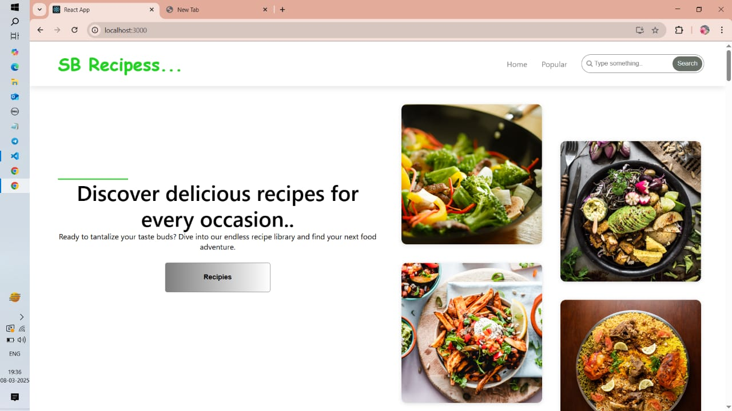

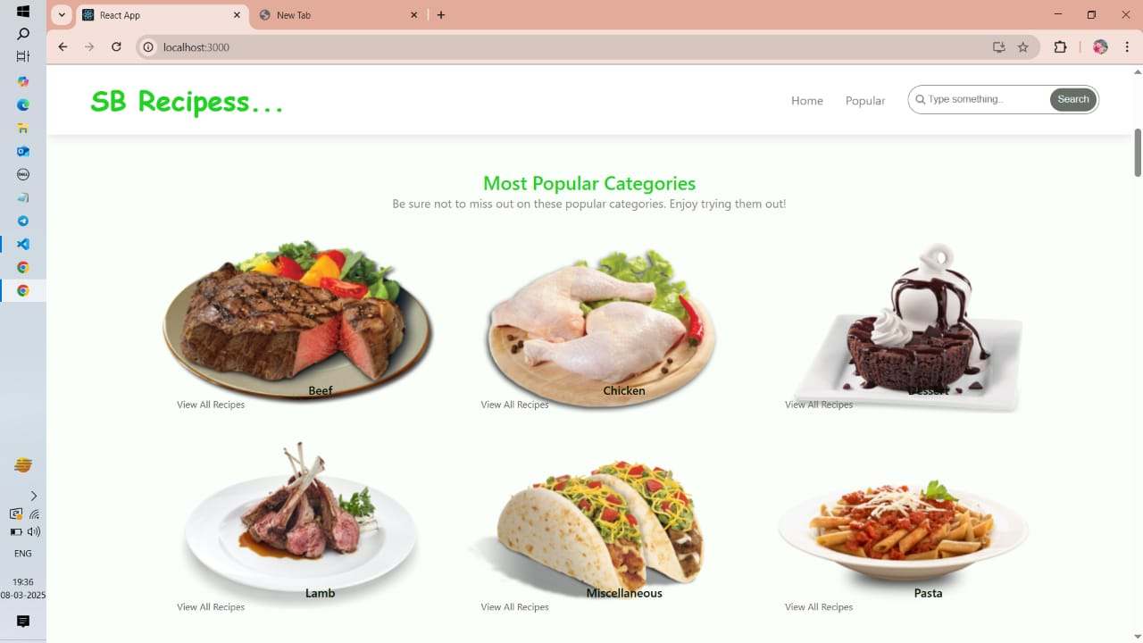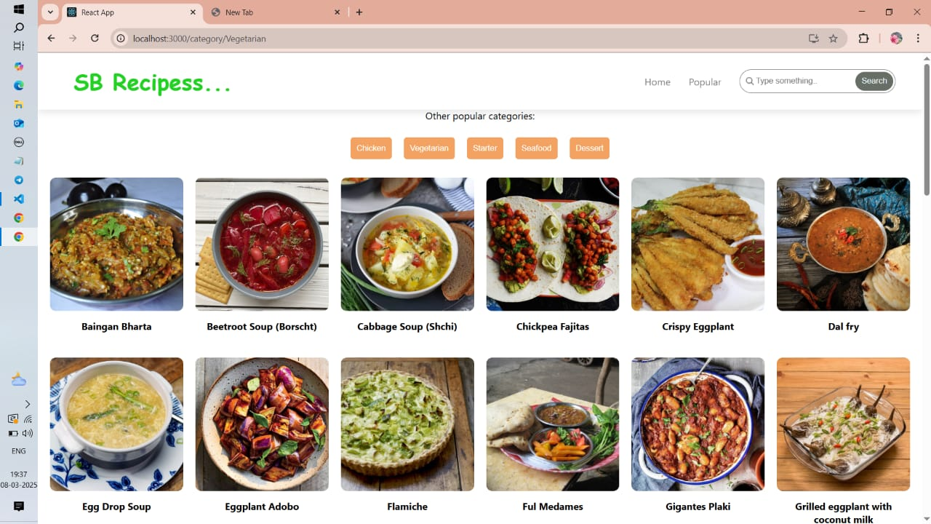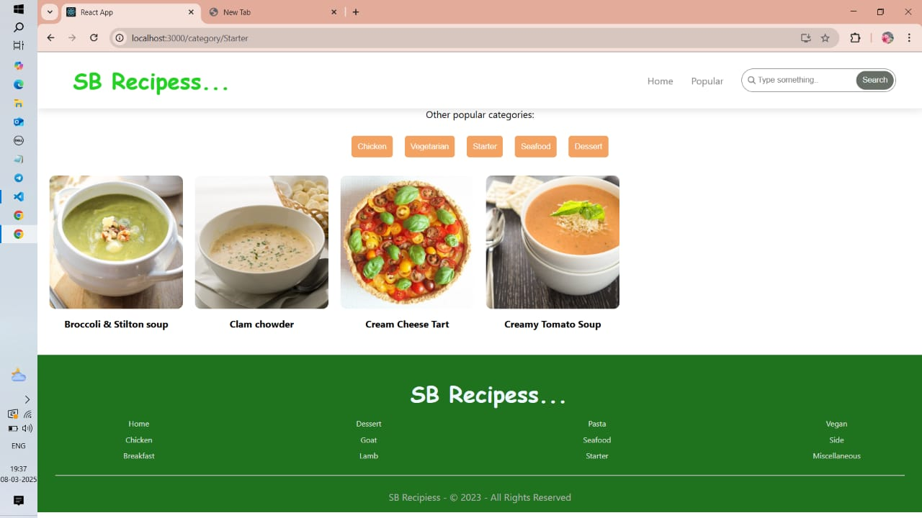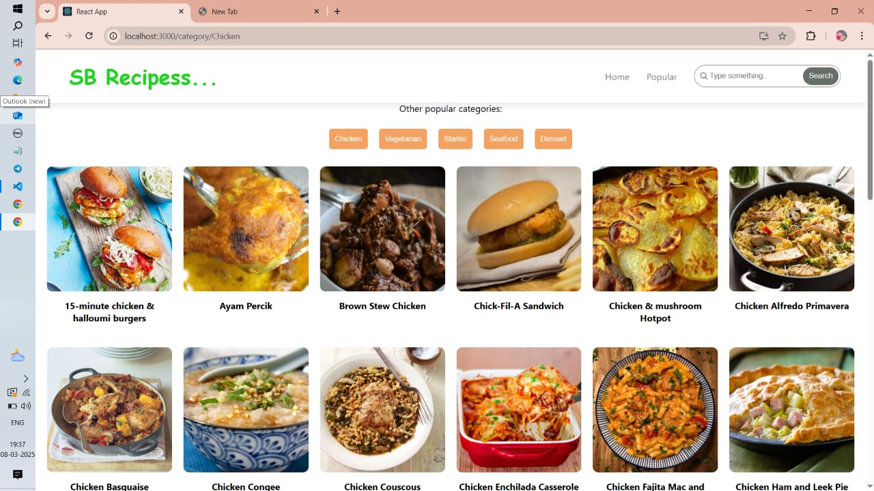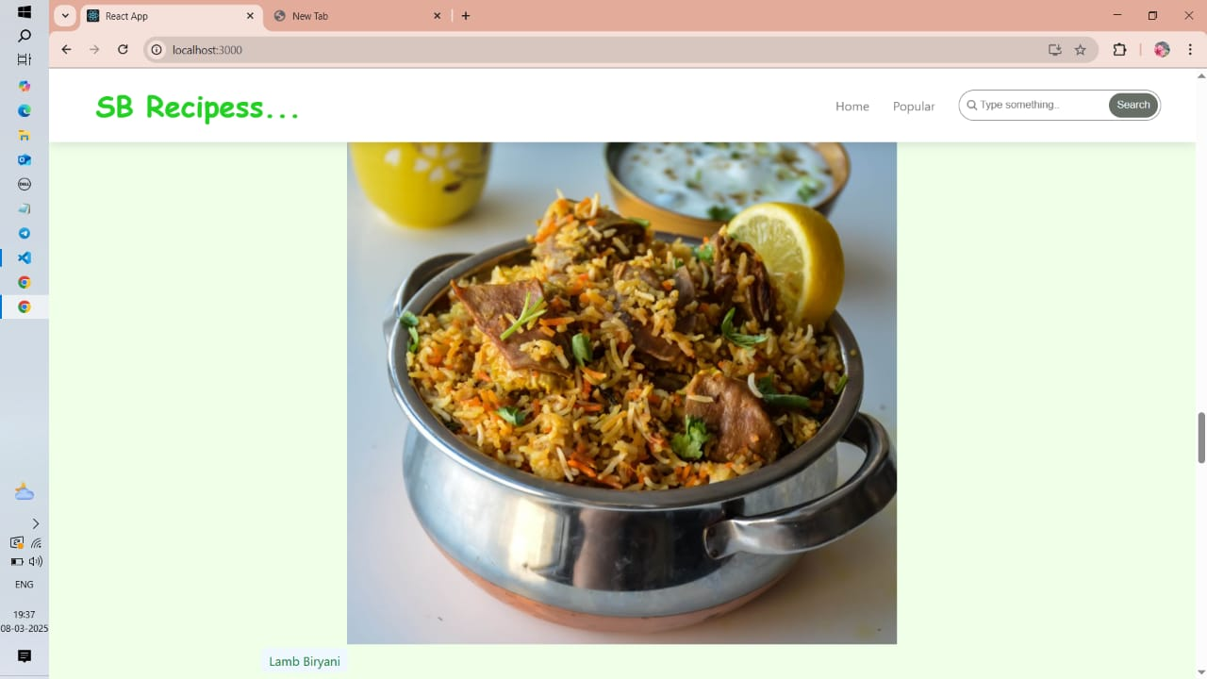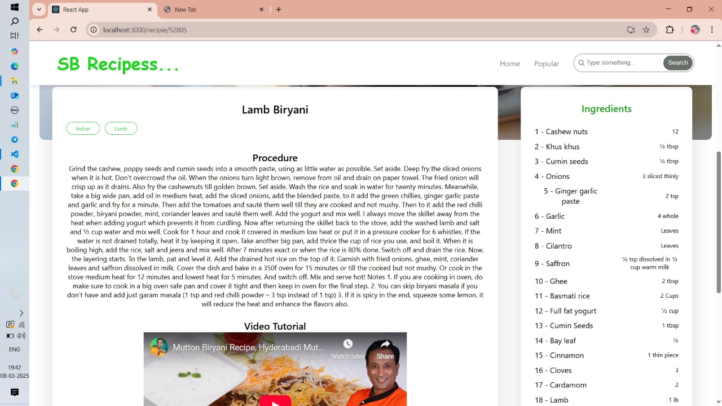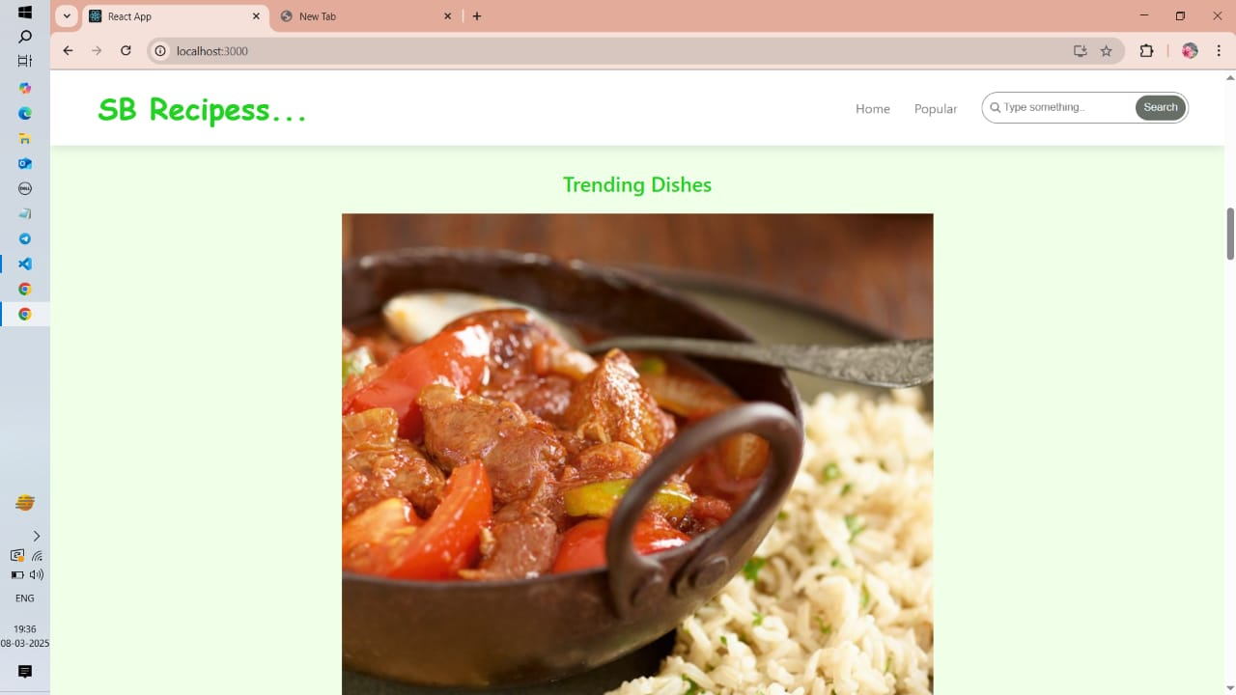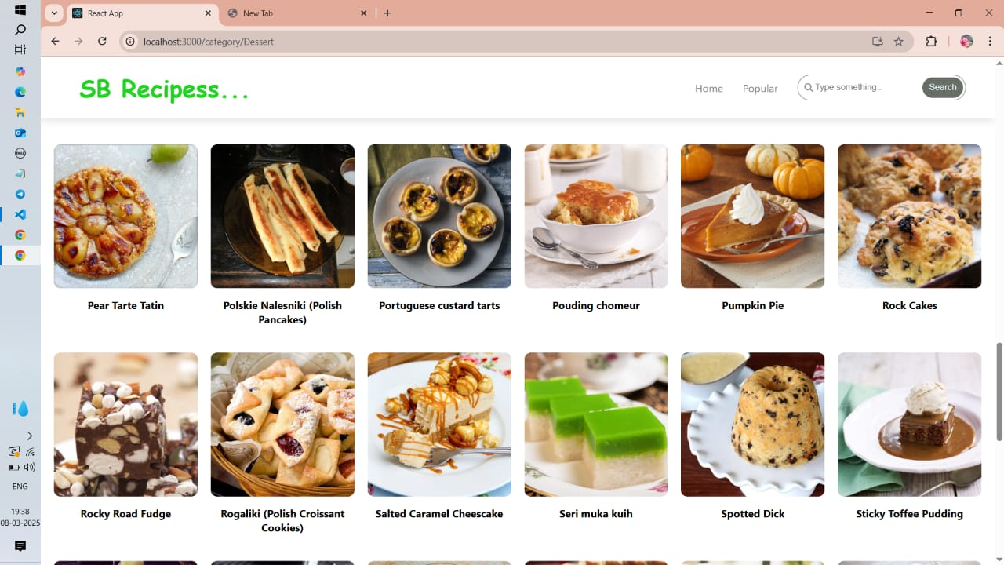

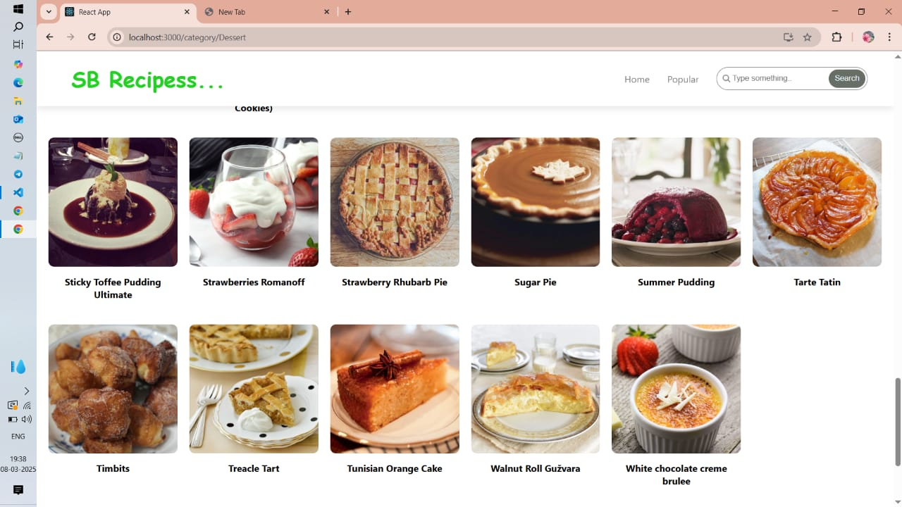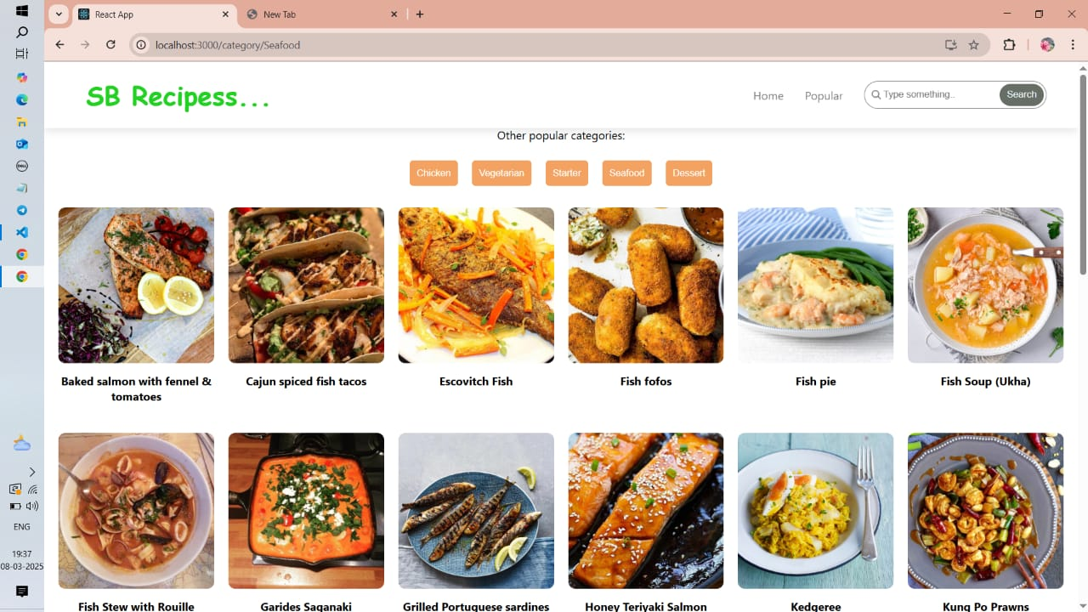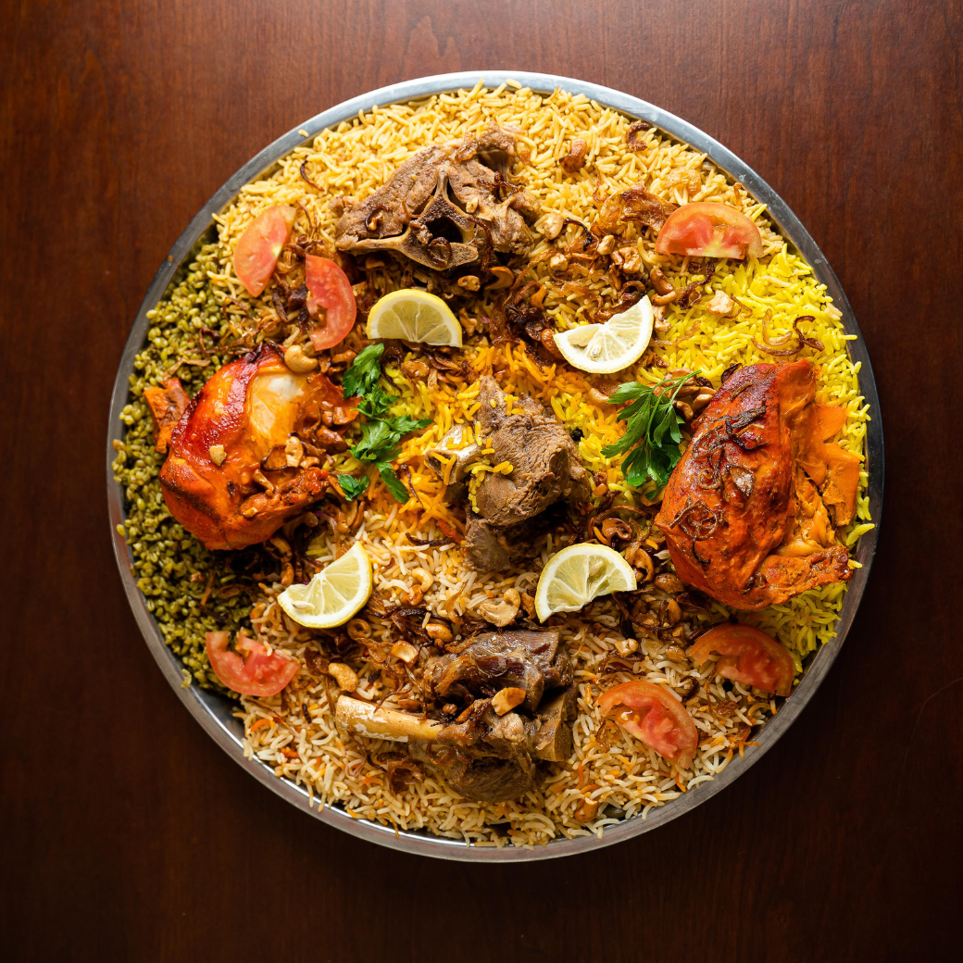

**KNOWN ISSUES**

Despite extensive testing, the CookBook application may have some known issues that could affect user experience. Below are some identified issues along with possible causes and solutions.

**1. Slow API Response**

📌 Issue:

* Recipe data takes longer to load, especially when fetching from the MealsDB API.

💡 Possible Cause:

* API rate limits or network latency.

🛠 Potential Solution:

* Implement caching mechanisms to store previously fetched recipes.
* Show a loading spinner while waiting for the API response.

**2. Search Function Case Sensitivity**

📌 Issue:

* The search feature does not return results if queries don’t match exact case.

💡 Possible Cause:

* The search logic is case-sensitive and does not normalize input.

🛠 Potential Solution:

* Convert both user input and recipe names to lowercase before comparison.

**3. UI Overlapping on Mobile Screens**

📌 Issue:

* Some UI components (e.g., navbar, buttons) overlap on smaller screens.

💡 Possible Cause:

* Missing proper media queries for responsive design.

🛠 Potential Solution:

* Adjust CSS breakpoints for better mobile compatibility.
* Use flexbox and grid layouts for dynamic positioning.

**4. Incorrect Category Filtering**

📌 Issue:

* Clicking on a category sometimes displays incorrect recipes.

💡 Possible Cause:

* The selected category state is not updating correctly.

🛠 Potential Solution:

* Debug state management in Category.js to ensure proper updates.
* Implement a useEffect() hook to trigger a new API call when the category changes.

**5. No Feedback on Failed API Calls**

📌 Issue:

* When the API fails, users don’t receive an error message.

💡 Possible Cause:

* No error handling implemented in API calls.

🛠 Potential Solution:

* Display error messages when API requests fail.
* Implement try-catch blocks and show fallback UI.

These issues will be addressed in future updates to enhance the performance, usability, and reliability of the CookBook application.

**FUTURE ENHANCEMENTS**

The CookBook application is designed to provide a seamless experience for recipe discovery and management. Below are potential future enhancements to improve usability, features, and overall performance.

**1. User Authentication & Profiles**

📌 Enhancement:

* Implement user sign-up and login functionality.
* Allow users to save favorite recipes to their profiles.

💡 Benefits:

* Personalized experience where users can bookmark and organize recipes.

**2. Shopping List Feature**

📌 Enhancement:

* Users can generate a shopping list from recipe ingredients.
* Option to add/remove items manually before shopping.

💡 Benefits:

* Makes grocery planning easier by providing a ready-to-use ingredient list.

**3. Meal Planner Integration**

📌 Enhancement:

* Allow users to schedule meals for the week.
* Provide caloric and nutritional breakdowns.

💡 Benefits:

* Helps users plan meals in advance and track their diet.

**4. Dark Mode Support**

📌 Enhancement:

* Implement a dark mode toggle for better user experience.

💡 Benefits:

* Reduces eye strain, especially during night-time browsing.

**5. Community Recipe Sharing**

📌 Enhancement:

* Enable users to submit their own recipes.
* Add a rating and review system for user-generated content.

💡 Benefits:

* Encourages community engagement and a wider variety of recipes.

**6. Offline Mode for Saved Recipes**

📌 Enhancement:

* Allow users to save recipes for offline access.

💡 Benefits:

* Users can view recipes without an internet connection, especially useful for kitchen use.

**7. Voice-Activated Cooking Assistant**

📌 Enhancement:

* Integrate voice commands for hands-free navigation.

💡 Benefits:

* Helps users follow recipes without touching the screen, making cooking more convenient.

**8. AI-Based Recipe Recommendations**

📌 Enhancement:

* Use AI to suggest recipes based on user preferences and available ingredients.

💡 Benefits:

* Provides personalized recommendations to match user tastes and dietary needs.